Cambridge Convent School

Final Term Examination

Class -1st

Subject -English

Part – A(Reader)

Q1. Write meaning of this word.

1. Arrives - _____________ 3. Grazing- ______________
2. Wipe- _______________ 4. Scared- _______________

Q2. Write the Hindi meaning of these words.

1. Happily- ________________ 3. Growing- _______________
2. Serve- __________________ 4. Scared- ________________

Q3. Write the rhyming word.

1. Many ___________________ _________________
2. Race ___________________ _________________
3. Night ___________________ _________________

Q4. Make sentence

1. Happy- ___________________________________________________________.
2. Clever- ___________________________________________________________.
3. Reward- __________________________________________________________.
4. Tasty- ____________________________________________________________.

Q5. Tick the right answer .

1.Apple grow on a __________________.

(a)Leaf ( ) (b)Tree ( ) (c)Branch ( )

2. Birbal was very __________________.

(a)Honest ( ) (b)Clever ( ) (c)Old ( )

3. Which fruit does Jinni like?

(a)Apple ( ) (b)Grapes ( ) (c)Banana ( )

4.Where do Kunal and Anshu live

(a)Goa ( ) (b)Delhi ( ) (c)Jammu ( )

1.Why did Akbar give Birbal a reward?

Ans._______________________________________________________________________.

2.What grow on a tree?

Ans._______________________________________________________________________.

3.With whom Anshu and Kunal going?

Ans._______________________________________________________________________.

4.What does Jinni like to eat?

Ans._______________________________________________________________________.

Q7.Fill in the blanks.

1. Kunal sits next to the_______________________.
2. He gave him a_________________ for his intelligence.
3. Suhani has a lot of_________________ to do.
4. Lambs are_________________ in the farm.

Q8.Write ‘T′ for true and ‘F′ for false.

1.Uncle Raj has a small farm. ( )

2.Their grandfather live in Delhi. ( )

3.″Yes,my lord” replied the Akbar. ( )

4.″As many as the hair an a horse′s tail”. ( )

5.Sneha and Pinky are sister. ( )

Q9.Complete the following lines.

Apples, apples

_____________ ___________________ ________________ tree.

Apples, apples

Pick __________________ _________________ _______________ ________________

Q10.Write the name of things to the given sounds.

1.Tip – Tip __________________________

2.Cheep – Cheep __________________________

3.Clap – Clap __________________________

4.Vroom – Vroom __________________________

Q11.Write the name of young ones.

1.Duck ___________________________

2.Hen ___________________________

3.Goat ___________________________

4.Cow ___________________________

5.Dog ___________________________

Part - B (Grammar)

Q1.Change the gender.

1.Uncle - ________________. 2.Monk - _________________.

3.King - _________________. 4.Son - ___________________.

Q2.Circle the plural and underline the singular .

1.The washerman wash the clothes.

2.The nurse take care of babies.

3.The leaf fell from the trees.

Thieves are afraid of man.

Q3. Make the singular for the following.

1.Flowers - ______________ 2. Apples - __________________

3.Bats - _________________ 4.Combs - ___________________

5.Shirts - ________________ 6.Hats - _____________________

Q4.Complete the following sentence with a ,an or the.

1._______ computer and _______ table.

2.Mummy has _________ big bag.

3.________aeroplane flies very high.

4._______ Sun and ________ Moon.

Q5.Write in, on or under.

1.The students are ___________ the class.

2.My brother is __________the roof.

3.The old man sitting ___________ the tree.

4.The eggs are_________ the nest.

Q6.Tick the correct words.

1.This/These cars are red.

2.Those/That tree are tall.

3.You can blow this/these balloon.

This/These is a house.

Q7.Fill in the blanks with is/am/are.

1.I _________ Vijay.

2.They _________ my friends.

3.This ________a car.

4.You _______ a lazy boy.

Q8. Fill in the blanks using has, had or have.

1. Neelam, Puja and Poonam _______________ got their gifts.
2. The table _______________ four legs.
3. The Chinese girls ______________ small eyes.
4. Geeta _____________ a good handwriting.

Q9. Fill in the blanks with and, but and or.

1. Is my answer right ____________ wrong?
2. That man is poor____________ happy.
3. ‘Goldilocks_______________ the three Bear′ is a nice book.
4. Will you come on Sunday_________________ Monday?
5. It is hot__________ wet.
6. An oranges is sweet__________ juicy.

Q10. Arrange the following jumbled words to make sentences.

1.is/work/worship ______________________________________

2.my/is/he/class/mate ______________________________________

3.policy/the/honesty/is/best ______________________________________

4.doctor/father/my/is/a ______________________________________

5.animal/our/is/tiger/national/the ______________________________________

Q11. Fill in the blanks.

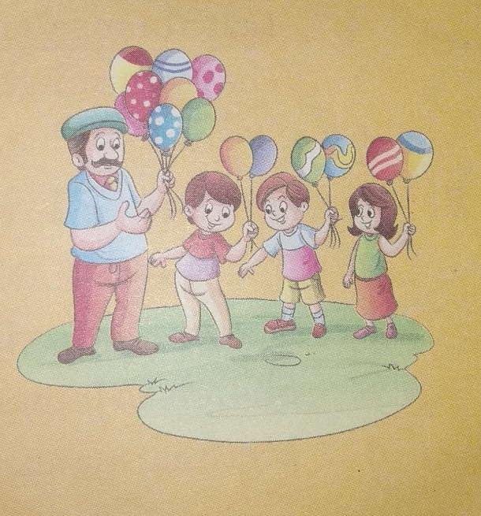

1.A man _______________ balloons.

2.The balloons _______________ colourful.

3.Children _____________ balloons.

4.Two boys _____________ four balloons.

5.One girl _____________ two balloons.

Q12.Match the following

(a)I can’t (1)Play football

(b)My friend can (2)Bark loudly

(c)My cat can’t (3)Drive a car

(d)My dog can’t (4)Run fast

Q13.Write opposite words

(a)Day - _______________________ (b)Happy - ______________________

(c)New - _______________________ (d)Dry - ________________________

Q14.Write a letter to a friend for inviting him on your Birthday.

Q15.Complete the Story.(Cow, Cheese, Nest, Cheese, Mouth, Fox, Cheese, Made, Sing, Angry, Beak, Back, Fell, Clever, Cheese)

One day a___________________ found some________________. He flew to his ________________ with the_______________ in his__________________. A hungry________________ wanted the _______________ . He _________________ fun of the crow and said that he could not ____________. The _______________ grow opened his __________________to answer _______________. The cheese________________ out. The ________________ fox ran away with the ___________________.

Q16.Write five line on ‘cow’.